Searching analysis

Linear search (worst case – element doesnt exists):

Vector size | Number of comparisons
10000 | 10000
20000 | 20000
30000 | 30000
40000 | 40000
50000 | 50000
60000 | 60000
70000 | 70000
80000 | 80000
90000 | 90000
100000 | 100000

Draw a graph of the dependence of the vector size and the number of comparisons:

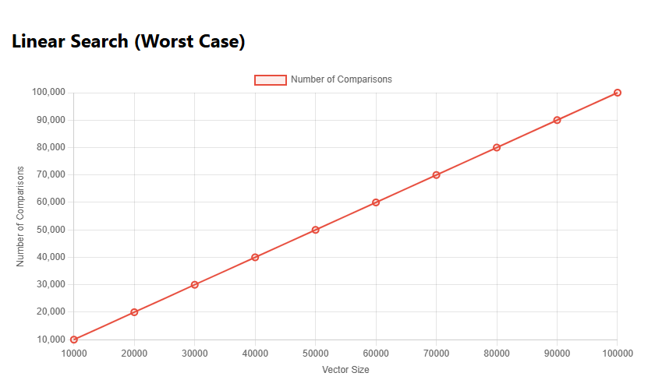

What is this relationship (quadratic, linear, logarithmic, linear-logarithmic)?:

-Linear

Binary search (worst case – element doesnt exists):

Vector size | Number of comparisons
10000 | 14
20000 | 15
30000 | 15
40000 | 16
50000 | 16
60000 | 16
70000 | 17
80000 | 17
90000 | 17
100000 | 17

Draw a graph of the dependence of the vector size and the number of comparisons:

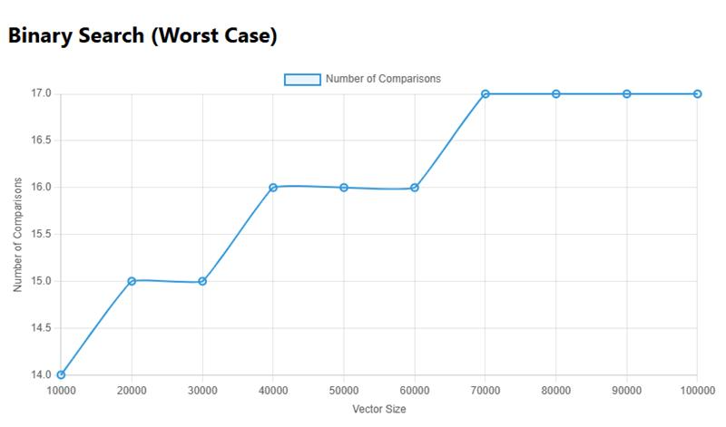

What is this relationship (quadratic, linear, logarithmic, linear-logarithmic)?:

-Logarithmic

